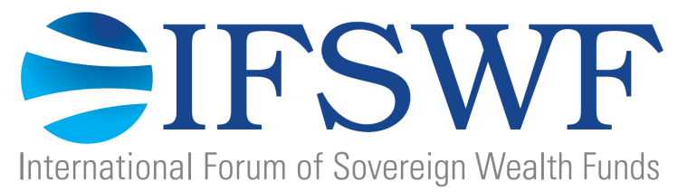

Role: Communications Manager

The International Forum of Sovereign Wealth Funds (IFSWF) is a global network of sovereign wealth funds (SWFs) headquartered in the City of London and established in 2009 to exchange views on issues of common interest and to facilitate an understanding of SWF activities and of the Santiago Principles. The Santiago Principles is a framework of principles and practices voluntarily endorsed by IFSWF members. The emphasis is on appropriate governance and accountability arrangements and sound, prudent conduct of investment practices. For more information on IFSWF and the Santiago Principles, please go to www.ifswf.org.

Is this your future role?

The Communications Manager reports directly to the Secretary General of the IFSWF Secretariat and is responsible for the smooth execution of the internal and external communications of the IFSWF. This includes the management of our digital presence (internal and external web and social media) and the execution of our strategic communications activities agreed with our board and members. You perform in the role in collaboration with colleagues and our strategic communications adviser in London.

The position is initially for a 2-year contractual term, which may be extended depending on performance. You should be eligible to work in the UK, and willing to work from our offices in the heart of the City of London. You will be expected to travel (up to 3 weeks per year) in connection with the execution of membership events. Your compensation will be reflective of your qualifications and negotiated individually. We offer a fixed salary, 28 days of annual leave and a good work-life balance. The IFSWF provides an equal opportunity to global talent with strong drive and willingness to perform.

Your key duties include:

- Implement the IFSWF communications strategy, media strategy and digital strategy in collaboration with our external communications adviser and our communications advisory group.
- Manage internal and external communications channels including the internal website, external website and social media. You will not be expected to have programming and web design skill, but rather be able to execute the day-to-day activities on the web.
- Editing and finalizing professional publications and drafting our Annual Report.
- Manage media, external stakeholder and peer organization inquiries.
- Successful organisation and execution of the communications aspects of the IFSWF Annual Meeting, and other membership events, including preparation of our press conferences and e-summaries from these events.
- Successful communications from the quarterly board meeting, including assisting with the preparation of agenda, background material and recording of minutes.
- Assisting our three subcommittees in terms of communicating their results and preparing minutes from their meetings.
- Continuously improve IFSWF’s communications function by capturing institutional knowledge, suggesting improvements, maintaining resources and information.
- Provision of periodic reports and administrative services to ensure the smooth running of the IFSWF Secretariat as directed by the Secretary General.

You probably have the following background:

- The position requires excellent written and verbal communication skills in English and ability to design communications output in a professional manner.
- Strong skills in the management of digital communications platforms, ideally with previous experience as web master or similar.
- Strong ability to build and deepen networks with media and execute professional media releases and execution of international events with top-notch communications.
- Ability to grasp complex concepts, and to articulate them in an accurate and easy-to-understand way.
- Strong academic qualifications and professional communications experience from a major company, ideally a membership organization or from the financial industry.

What sets you apart as a person?

- A results-driven mindset and willingness to work hard within a young global organization with an ambitious work program and growing membership.
- An extroverted personality with strong attention to detail and ability to turn ordinary communication tasks into extraordinary results.
- Ability to work independently in a quickly evolving organization where each day brings new challenges.
- Familiarity with sovereign wealth funds and the institutional investment industry is a strong plus.
- A dedicated team player with lots of positive personal energy.

How to apply

Please forward your application, CV, references and illustration of previous communications work to us before 30 November 2015 via secretariat@ifswf.org. If you have questions, please call Kristian Flyvholm, Secretary General of the IFSWF Secretariat on +44 (0) 7477 582310.

